How to Copy from PDF Files
- Open the pdf file for which you want to get information.
- In Adobe Acrobat, click on the Edit button on the menu.
- Move down and click on the “Take a Snapshot” selection. Doing this will allow you to take a picture or copy a section of the pdf.
- When you move your mouse over the pdf file, the arrow turns to a cross (plus). Use this arrow (plus) to guide your mouse into a square or rectangle around what you are copying. Click and drag ( hold the left button down on the mouse and keep it down as you move the mouse) around the object you are copying. The area will be shaded. Once you let go of the button you will see a dialog box that says the object is now saved to your clipboard.
- Open up the program you will use the copied object in. I usually use a word processing program.
- Place your mouse on the document and right click (click the right button on the mouse).
- Move the mouse down to “paste.” Once you do that you should see the object that you copied now in your document.
Click on the edit button on the menu. Then move down to “Take a Snapshot.”

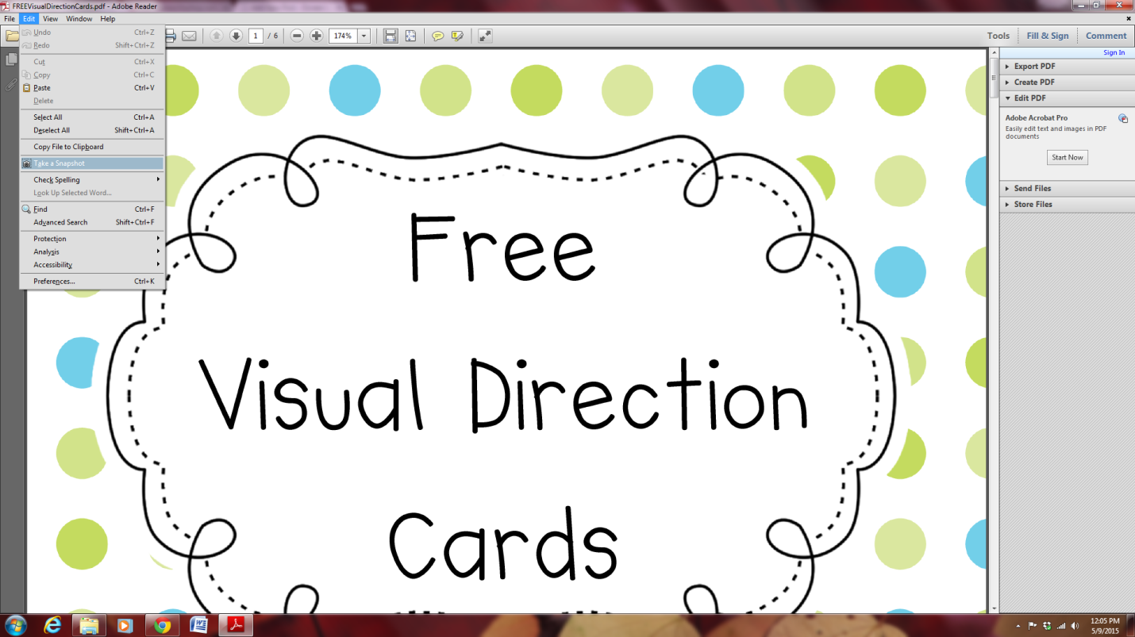

Take a Snapshot

Prepared by Doreen Orr, doreensrockin3rdgrade.com 2015

