Joe Shmoe’s





[](javascript:window.opener.immDownload('j0125461','77',escape(window.opener.content.location.href),'1'))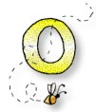 Mrs. Orr

2nd Grade

Rosenauer Elementary School